**READ ME**

The multiple Linear Regression Model best suggests a way to observe the variations in the Reflection Loss vs the atomic Radii’s. A plot between the cationic radii’s and the reflection loss is presented as below suggesting an almost linear relationship between the output and the input parameters.

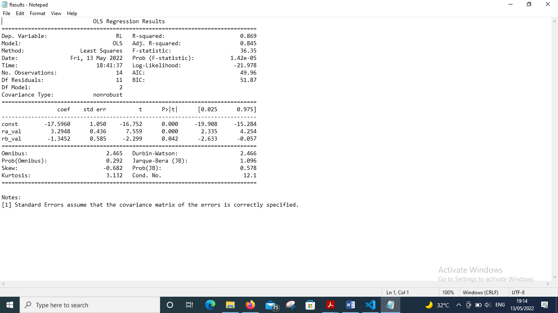But in order to first apply the multiple linear Regression Model, validation of the significance of the input features is done by applying Ordinary Least Square (OLS) method of the statsmodel library in python. There are two results in the OLS model summary that are of interest to us. First is the Coefficient of Determination(R squared-R2), second is the p-value. $R^{2}$ measures the amount of variation in the output feature captured by the corresponding variations in the input parameters while the second value is the p-value which provides a conditional probability of a null output hypothesis. If the p-value is less than the significance value of 0.05 , the input features does not fulfil the null hypothesis. The OLS model summary

Figure 6: Linear Relationship between Reflection Loss and the Cationic Radii

Figure 7: OLS MODEL SUMMARY

From the model designed above a GUI is developed for calculating the Reflection Loss , a perovskite compound and its effective permittivity based on the atomic radii provided by the user.